2018 FIRE TRUCK PULL CHAMPIONS  MONON FIRE DEPARTMENT  MONTICELLO FIRESTATION  Retired Monticello Fire Station |  |  | Spirit of Monticello Festival Mission Statement:  The purpose of the festival is to encourage a strong sense of community, family and friendship by celebrating the beginning of our summer season on the Lakes.  We strive to stimulate local business and community awareness by supporting a large variety of musicians, artisans, vendors and family activities.  Participants in our festival games, activities and contests help foster a sense of true community spirit. It is our goal to welcome you and make you feel home. A place that you will always come back to…. a place called Monticello, Indiana.  Sincerely, Spirit Committee  www.spiritofmonticello.org  Contact Us  Lee Ann Reinholt  White County Coordinator  PO Box 962  Monticello, In 47960  765-460-2555  whitecountyso@yahoo.com |  |  | Are teaming up for the  2nd Annual Fire Truck Pull  When: June 22nd, 2019  Where: Broadway Street between Railroad St and Illinois St  Time: 5 pm – 9 pm  Teams of 8 to 10 people  pulling a Fire Truck!  Proceeds to benefit  White County Special Olympics

The mission of Special Olympics is to provide year-round sports training and athletic competition in a variety of Olympic-type sports for children and adults with intellectual disabilities, giving them continuing opportunities to develop physical fitness, demonstrate courage, experience joy and participate in a sharing of gifts, skills and friendship with their families, other Special Olympics athletes and the community.  Through the power of sports, people with intellectual disabilities discover new strengths and abilities, skills and success. Our athletes find joy, confidence and fulfillment -- on the playing field and in life. They also inspire people in their communities and elsewhere to open their hearts to a wider world of human talents and potential.  White County Special Olympics  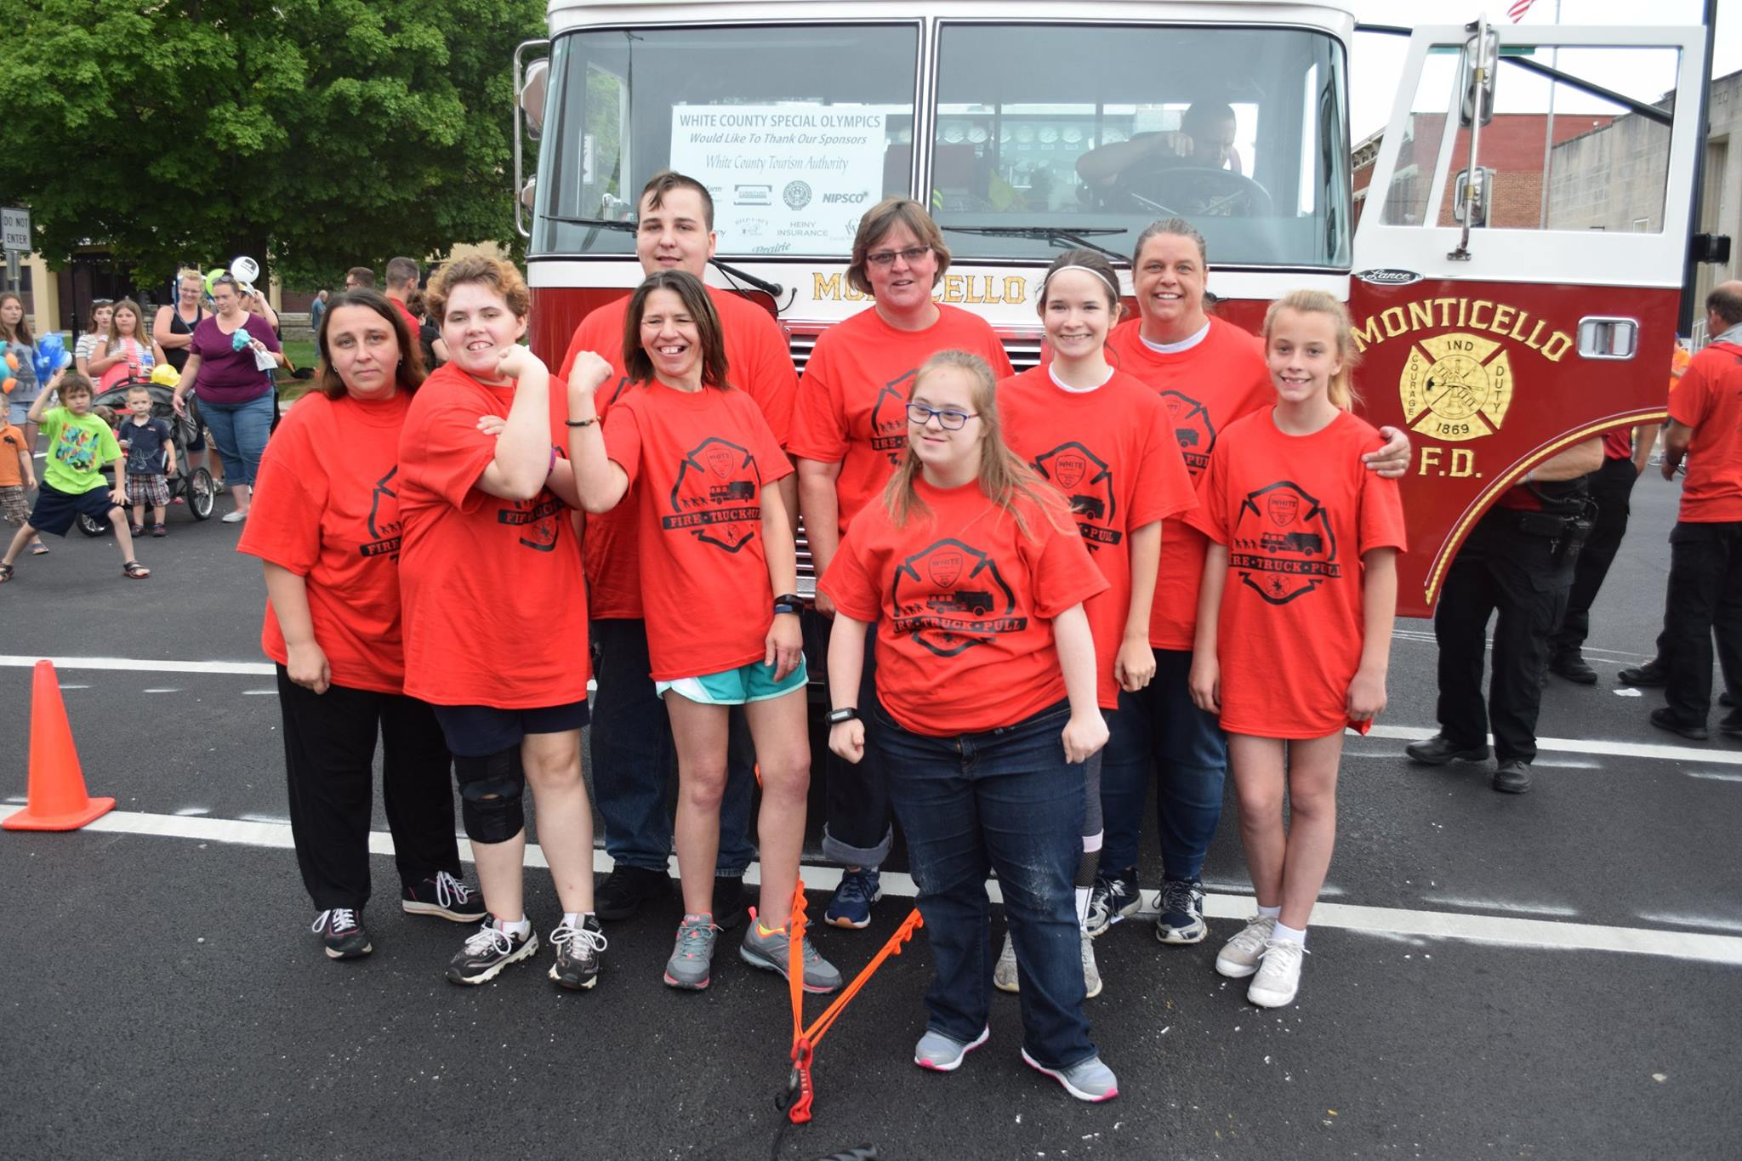  One of our Teams for the Fire Truck Pull! |  |  | - Team registrations received by May 31st will receive “official” Fire Truck Pull t-shirts for team members.  - Registration must include the registration fee of $200/Team plus  - A Team Registration Form and signed waiver (on day of event).  - Mail to: White County Special Olympics, % Fire Truck Pull, PO Box 962, Monticello, In 47960 Please allow at least 7 days for USPS delivery.  - Or Email registration/waiver forms to whitecountyso@yahoo.com (preferred)  - Team Captain must register team on site day of event to receive any further instructions.  Email: whitecountyso@yahoo.com for registration forms  Or look on the www.spiritofmonticello.org website to obtain them as well. |  |  | Message from Chief Logan  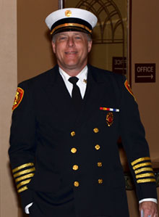  I would like to offer a warm welcome to our local citizens and visitors to the Monticello community. I am proud to serve as the Fire Chief of the City I have called home for more than 50 years. We would like to extend an open invitation to our community and visitors to tour our department and learn about the services we proudly provide.  The Monticello Fire Department is the only full-time fire department in our county. We provide Fire and ALS Ambulance services to the City of Monticello, several townships, and parts of neighboring Carroll County.  The men and women of our department respond to well over 3000 calls for emergency services per year. Our 23 Firefighter/Paramedics and 6 Part time Firefighter/EMTs are working around the clock to keep our residents and lake visitors safe.  Be Safe  Chief Galen Logan

